Poster setup Guide for PC.

The following is a step-by-step guide for creating your poster using Microsoft PowerPoint 2007 and 2010 for PC.

- To create a poster in PowerPoint, first determine the final dimensions of your poster.
- Find out if the meeting you are attending has any size guidelines or restrictions.
- The size you choose should follow conference guidelines and be an appropriate size for your data.
- The maximum dimension that PowerPoint allows for height and width is 56 inches. If it is longer, you’ll need to work at half size, and we’ll double when we print.
Note: In addition, our paper roll is 42” wide, so although your poster can be up to 56” long.
(PowerPoint’s maximum, the width must be 42”or less).
B
A
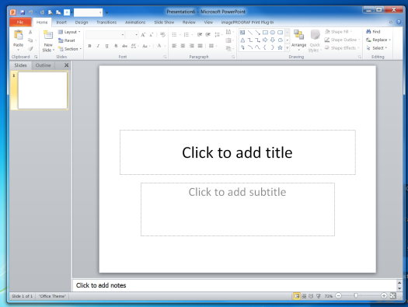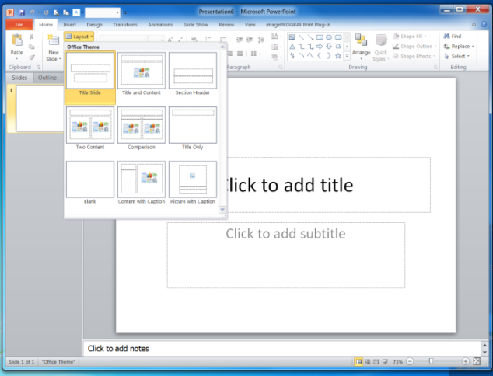
4. Select the
Blank layout
- Open a new PowerPoint slide presentation and close the Slide and Outline Pane
2. Click on the Home Tab
3. Click the Layout
D
C

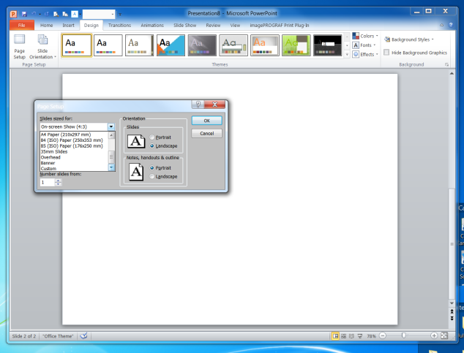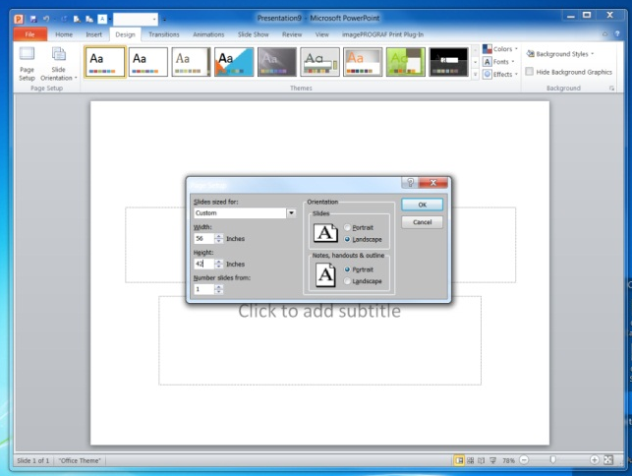
10. Click the Ok Button
7. Select Custom from “Slides sized for, ” drop-down menu

5. Click on the Design Tab
6. Click the Page Setup

8. Select the “Orientation” of the poster.
9. Enter the “Width and Height”
E
F

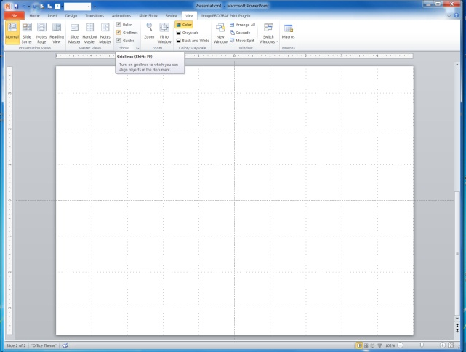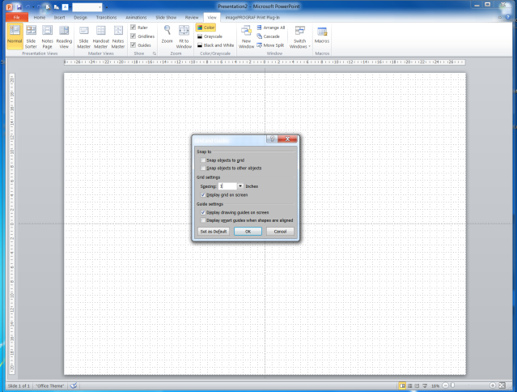
12. Check the Ruler and Gridlines and Guides boxes
11. Click on the View Tab
14. Select 1 inch from the Grid setting spacing box.
15. Check Display grid on screen box.
16. Check Display drawing guides on screen.
17. Click Ok button
13. Click Show arrow, the following Grid and Guides window will appear.

