Study Closure Submission: Guidance
- A new submission type, called “Study Closure” will be implemented for use by investigators to close their study with the IRB.
- Instead of submitting a “Continuing Review” submission and selecting the option within the CR form to designate study closure, a study closure will be submitted on its own submission type.
- Additionally, the new Study Closure submission form has features built in that allow the member of KSP completing the form to route the submission to the Faculty Advisor, Department Chair, or Division Chief for signature if the PI left VU/VUMC prior to closing their study.
- Allowing another individual with a leadership role to close a study if the PI left VU/VUMC ensures the IRB is still able to gather accurate information about the status of the study prior to closure. This ensures compliance with federal regulations/HRPP policies.

- This is what the Study Closure submission looks like from the researcher’s view:
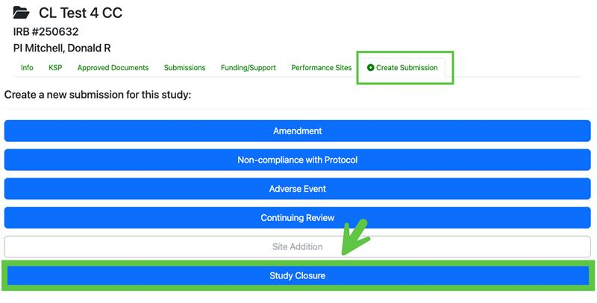

- If the researcher selects the option that the PI left VU/VUMC and the PI had a Faculty Advisor who is still here, the submission will automatically route to the Faculty Advisor for signature.

If the study did not have a Faculty Advisor or the Faculty Advisor also left VU/VUMC, the researcher will be prompted to enter the name of their Department Chair or Division Chief when they submit the Closure. The submission will route to that individual for signature.

See screenshots below:
