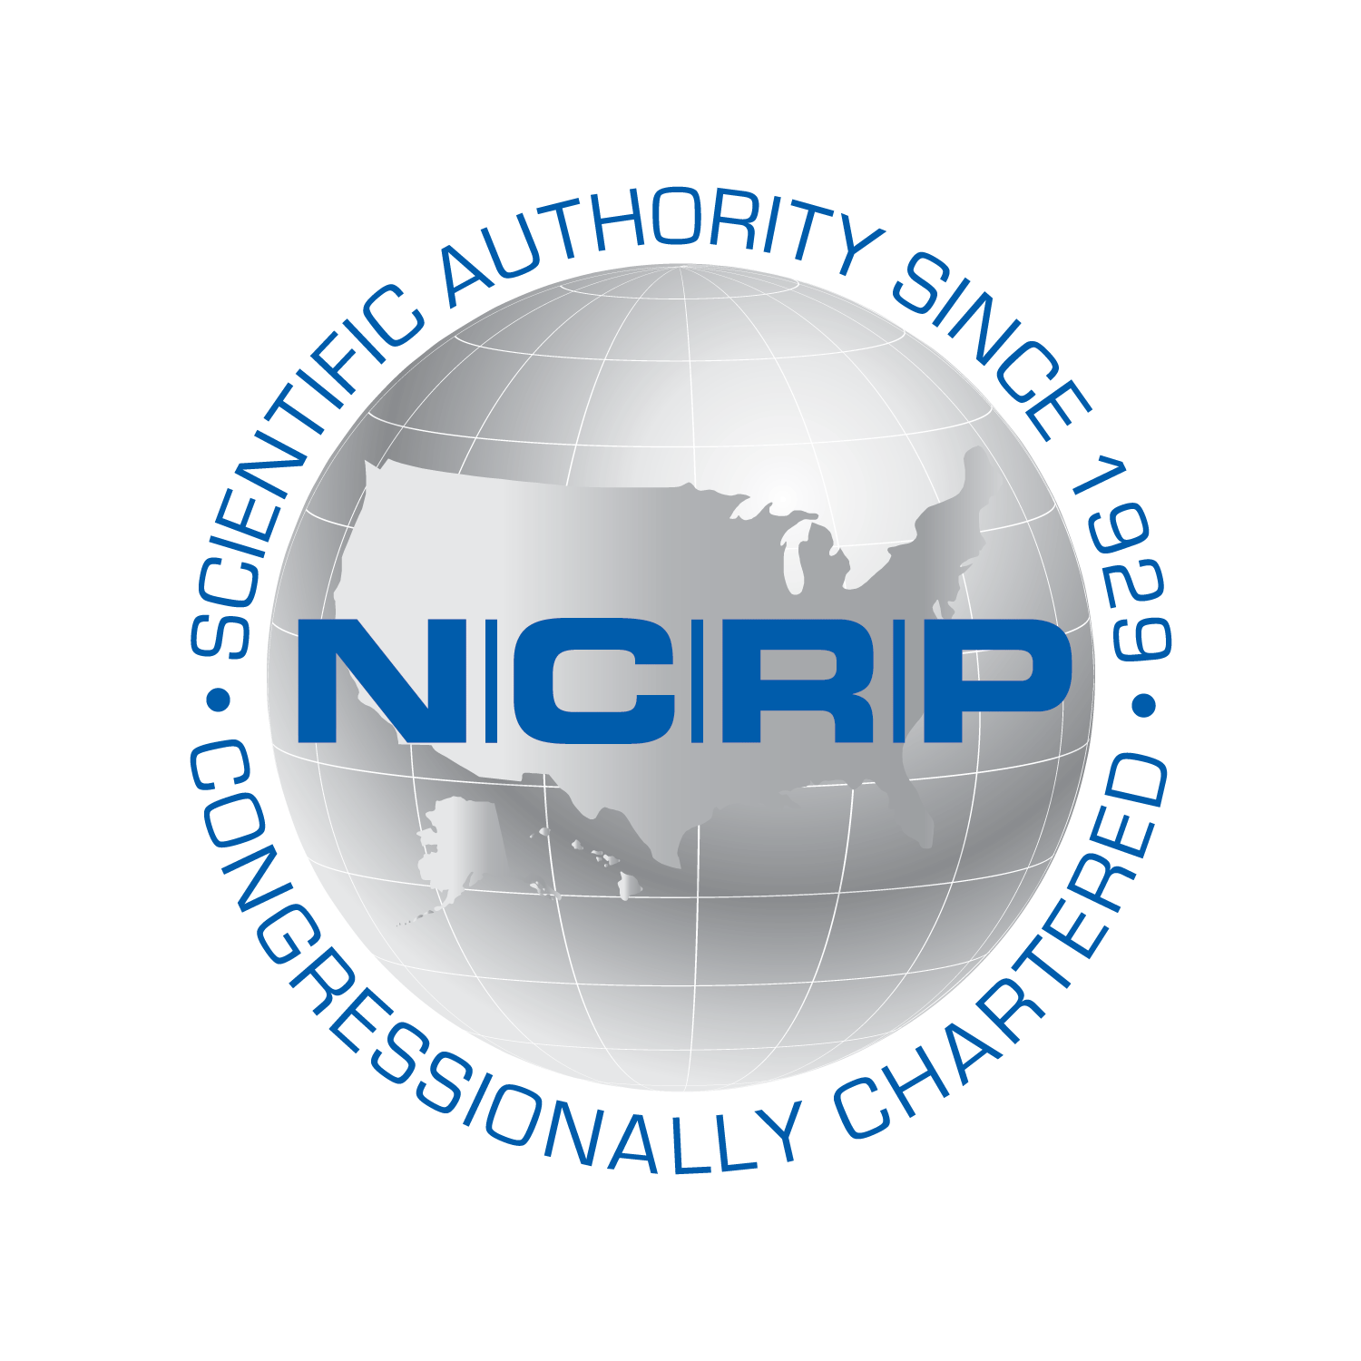
John W. Poston, Sr.
July 8, 1937 – September 23, 2025
In Memoriam
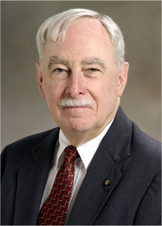
The NCRP family is deeply saddened by the passing of Dr. John W. Poston, Sr.
Dr. Poston, Professor Emeritus of Nuclear Engineering at Texas A&M University, passed away in Bryan, TX on September 23, 2025, at the age of 88, with his wife, Ann Wallingford, at his side. A memorial event is planned for Saturday, November 8, at 2:00 PM in the Zachry Engineering Education Complex, Chevron Room, at Texas A&M University.
Born on July 8, 1937 in Sparta, TN, Dr. Poston was a pioneering health physicist, educator, and mentor whose influence on radiation protection and nuclear engineering will be felt for decades to come. With a bachelor’s degree in mathematics from Lynchburg College, and master’s and Ph.D. degrees in nuclear engineering from the Georgia Institute of Technology, Dr. Poston devoted his career to advancing the science and practice of radiation safety and dosimetry, helping to shape standards for both occupational exposure and national emergency response. He served as Professor and Chair of the Department of Nuclear Engineering at Texas A&M University for 10 years and earlier held positions at the Georgia Institute of Technology, Oak Ridge National Laboratory, and in industry.
Dr. Poston was elected as a Distinguished Emeritus Member of NCRP after serving 12 y on the Council. He served as the Scientific Vice President for Program Area Committee 3 on Nuclear and Radiological Security and Safety. He chaired scientific committees: (SC) 2-1 which published Key Elements of Preparing, Protecting and Equipping Emergency Responders for Nuclear and Radiological Terrorism (NCRP Commentary No. 19); SC 2-2, Responding to a Radiological or Nuclear Terrorism Incident: A Guide for Decision Makers (NCRP Report No. 165); and SC 46-14, Management of Terrorist Events Involving Radioactive Material (NCRP Report No. 138). He presented the First Annual Warren K. Sinclair Keynote Address at the NCRP 2004 Annual Meeting and gave the 40th Lauriston S. Taylor Lecture at the 2016 Annual Meeting.
A past president of the Health Physics Society, Dr. Poston was also a Fellow of the Health Physics Society, the American Nuclear Society, and the American Association for the Advancement of Science. He chaired key committees for the National Council on Radiation Protection and Measurements, providing guidance on managing radiological incidents and safeguarding the public.
His groundbreaking work in both external and internal dosimetry, along with his many influential publications and lectures, set the benchmark for excellence in the field. Among many honors, he received the Founders Award from the Health Physics Society (HPS) and the Loevinger-Berman Award from the Society of Nuclear Medicine, recognizing a lifetime of achievement and impact. He was also awarded the HPS Robley D. Evans Commemorative Medal in recognition of his long and distinguished career.
Beyond his professional accomplishments, Dr. Poston will be remembered for his warmth and generosity as a teacher and mentor. He was a valued colleague as a teacher, academic and researcher. He inspired generations of students and colleagues with his insight, his high standards, and his unwavering dedication to the health physics community. His legacy lives on in the people he guided, the standards he helped define, and the safer world he worked tirelessly to create. We honor his memory with gratitude and deep respect.
In addition to his wife, Ann, he is survived by his stepchildren Katy, Erica (Kyle) and Brent (Karly); step-grandchildren Clayton, Emma, Claire and Harper; children Martha, Vera (Berlin) and Jay; grandchildren Stephanie, Carrie, Rebecca, Allison, Jason, Alexis and Jake; and his brother Bill (Elizabeth). He was preceded in death by his parents, Gordon and Martha Poston.
In lieu of flowers, the family requests that memorial donations be made to the Friends of John Poston, Sr. Scholarship Fund (http://give.am/JohnPostonScholarship) that was established a few years ago by several Former Students and professional colleagues to support undergraduate students majoring in nuclear engineering.

