Parker B. Francis Fellowship Program Class of 2025
Reem Aboushousha, PhD
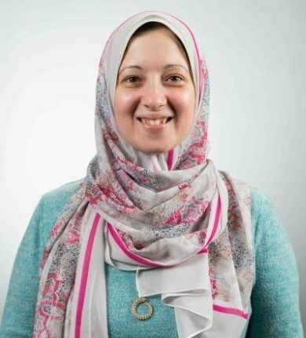
Targeting glutathione pathway to overcome drug resistance in lung adenocarcinoma
Lung cancer is a deadly disease with poor survival. Current chemotherapeutic medications have serious side effects in addition to not being effective after some time. Previous studies highlight increases in the antioxidant glutathione as a possible reason for chemotherapeutic resistance. I discovered that glutathione changes the function of a key protein involved in tumor pathogenesis, named ovarian tumor deubiquitinase1 (OTUB1). Several studies report that cancer patients with altered levels of this protein have an aggressive tumor that does not respond well to therapies. Work in this proposal aims to understand the reasons behind chemotherapeutic resistance in lung cancer and whether OTUB1 protein is involved. Additionally, we are trying to find ways to overcome this resistance with compounds that can potentially be developed into new drugs.
Mentor: Yvonne Janssen-Heininger, PhD
Institution: University of Vermont and State Agricultural College

Lindsay M. Forbes, MD

Right Ventricular Response to Exercise Among Patients with COPD
Chronic obstructive pulmonary disease (COPD) is common. Patients with COPD often have right ventricular (RV) dysfunction which worsens symptoms and mortality. Treatments to improve RV dysfunction are needed. Exercise training can improve RV dysfunction, but a lack of personalized recommendations limits its effectiveness. This proposal will evaluate patients with COPD using transthoracic echocardiography to identify patterns of RV response to exercise. We hypothesize that some patients with COPD increase RV contractility during moderate-intensity exercise but suffer “contractile exhaustion” during high-intensity exercise. For these patients, we will test whether exercise that causes positive RV contractility responses through moderate-intensity interval training is feasible. This proposal will help develop personalized exercise training programs to improve RV dysfunction to improve symptoms and survival in patients with COPD.

Mentor: Tim Lahm, MD
Institution: University of Colorado Denver

Sheiphali A. Gandhi, MD, MPH

Complex Occupational/Environmental Exposure Assessment and Pulmonary Fibrosis
Pulmonary fibrosis (PF) is a lung condition that causes breathlessness due to lung scarring. It is often seen in interstitial lung diseases (ILDs). ILDs can be deadly and costly to treat. Some ILDs have unknown causes, but workplace or environmental fumes and dust can lead to PF by causing lung inflammation and scarring. I will use advanced methods to study diseases in exposed populations and investigate this issue. First, I'll identify jobs linked to PF. Then, I'll assess how living conditions and air quality affect the risk. Lastly, I'll compare disease severity in those with high and low exposures to air pollution and workplace dust and fumes to understand their combined impact. My research can inform policies to protect vulnerable workers and communities from PF.

Mentor: Prescott G. Woodruff, MD, MPH
Institution: The Regents of the University of California, San Francisco

Jose Gomez-Arroyo, MD, PhD


Role of FOXF1 in the Pathobiology of Pulmonary Arterial Hypertension
Pulmonary arterial hypertension (PAH) is a life-threatening condition where high blood pressure in the lung arteries disrupts blood flow between the heart and lungs, often leading to heart failure. Our research focuses on the role of a protein called FOXF1, which is essential for forming healthy lung blood vessels during development. We have found that PAH may occur in adults when FOXF1 becomes deficient or altered. To investigate this hypothesis, we will use advanced model systems, including organoids (small, lab-grown versions of organs made from stem cells) and a novel transgenic mouse model with cell-specific reductions in FOXF1 expression. Additionally, we will evaluate a nanoparticle-based gene therapy, like the technology used in COVID-19 vaccines, to restore FOXF1 function specifically in lung blood vessels.

Mentor: Jeffrey A. Whitsett, MD
Institution: University of Cincinnati

Gillian C. Goobie, MD, PhD, FRCPC

Identifying environmentally-sensitive targets in idiopathic pulmonary fibrosis
Idiopathic pulmonary fibrosis (IPF) is a disease that causes lung scarring and results in breathing difficulties and early death. Air pollution is associated with IPF development and progression, but we do not understand why. This project aims to answer this question by looking at how air pollution contributes to scar tissue within the lungs through a process called DNA methylation that controls whether genes are turned on or off. We will match satellite-derived air pollution levels with lung imaging and DNA methylation data from patients with IPF compared to healthy individuals to understand how lung scarring occurs in response to pollution. This research will help uncover how pollution contributes to lung scarring in IPF and may identify new targets for therapies to reverse this
process.

Mentor: Tillie L. Hackett, PhD, ATSF
Institution: University of British Columbia

Jason L. Guo, PhD
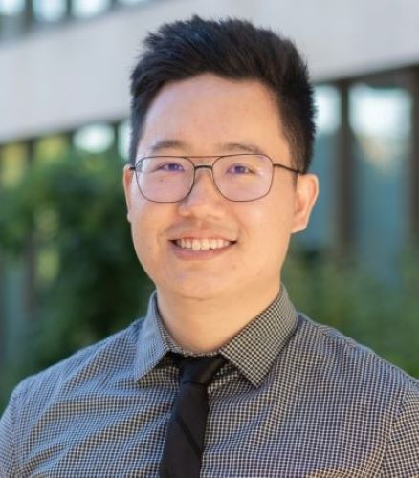
Dissecting Lung Spatial-Biological Niches in Early Fibrogenesis
Interstitial lung diseases (ILDs) affect >5,000,000 patients globally. ILDs often result in a mixture of (1) healthy tissue, (2) early scar tissue, and (3) mature scars, which may all be simultaneously present within the same patient. Each of these different types of tissue has a unique assortment of cells and proteins. However, traditional biological methods, which often examine lung tissue in bulk, may not be able to distinguish the factors unique to each tissue type. This project uses cutting-edge biology and bioengineering techniques to study how the cell/protein composition of early scar regions functionally differs from healthy tissue and mature scars. This will enable us to design new therapeutic testing models specific to the onset of scarring, while enhancing our understanding of early disease progression.

Mentor: Michael T. Longaker, MD, MBA, FACS
Institution: Stanford University School of Medicine

Genta Ishikawa, MD, MPH
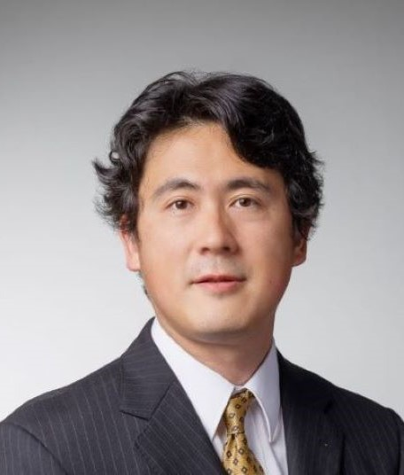
Noradrenaline Mediated Fibroblast Activation in Idiopathic Pulmonary Fibrosis Idiopathic Pulmonary Fibrosis (IPF) is a severe lung disease that causes significant scarring and has an average life expectancy of about three years following diagnosis. Existing medications are only moderately effective and often cause severe side effects, underscoring the urgent need for better treatment. My recent findings indicate that noradrenaline from the nervous system interacts with α1-adrenoreceptors to influence scar-forming cells called myofibroblasts. This proposal seeks to explore this noradrenaline-myofibroblast interaction more deeply by analyzing human IPF samples, conducting cell culture studies, and utilizing animal models. The goal is to understand these mechanisms well enough to consider repurposing α1 adrenoreceptor blockers that are currently used for other conditions as a new therapeutic approach for IPF.
Mentor: Erica L. Herzog, MD, PhD
Institution: Yale University

Ruihua Ma, PhD

Regulatory T Cells as Mediators of Pulmonary Fibrosis
Idiopathic pulmonary fibrosis (IPF) is a chronic lung disease characterized by progressive and irreversible lung scarring, with an average survival time of 3–5 years after diagnosis and few treatment options. Regulatory T cells (Tregs) are essential for tissue repair following acute lung injury; however, their prolonged presence can lead to abnormal tissue remodeling. Treg cells produce amphiregulin (AREG), which may activate fibroblasts that express the AREG receptor, epidermal growth factor receptor (EGFR). Activated fibroblasts produce collagen and contribute to fibrosis. We aim to uncover the spatial dynamic between Treg cells and fibroblast and define the causal role of AREG-EGFR signaling in the progression of pulmonary fibrosis.

Mentor: Karen M. Ridge, PhD
Institution: Northwestern University

Karolina Maciag, MD, PhD

Interferon gamma regulates inflammation in a cell-extrinsic manner to control TB
Tuberculosis (TB) remains the global leading cause of death from a single infectious agent. Efforts toward development of effective TB vaccines and host-directed therapies have been hampered by a lack of understanding of immunity to Mycobacterium tuberculosis (Mtb). The studies described here address key unanswered questions about how immune cells and pathways can control TB, which will help develop better ways to treat and prevent TB disease. The cytokine interferon gamma (IFNγ) is essential to TB immunity, but how it works remains unclear. Here, we use cutting-edge immunologic research tools to challenge the existing model of how IFNγ affects the key Mtb infected host cell, the macrophage. I propose experiments to uncover mechanisms by which IFNγ regulates immunometabolic state and inflammation and curtails the recruitment of potentially harmful immune cell types. I then explore how to target these pathways with therapeutics to improve TB disease outcomes.

Mentor: Kevin B. Urdahl, MD, PhD
Institution: University of Washington

Abraham Scott McCall, MD, PhD
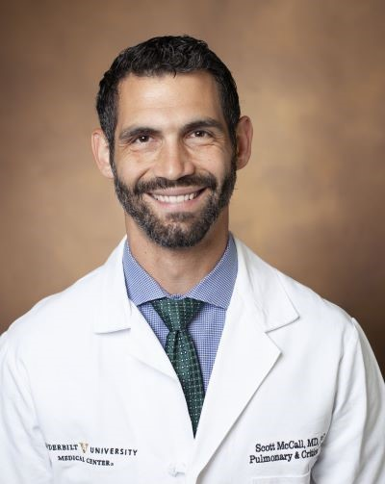
Modulation of alveolar regeneration by Hypoxia-inducible factor (HIF)-driven signaling
Most patients with Pulmonary Fibrosis (PF) succumb to their disease or require lung transplant within 5 years of diagnosis, and new treatments that stabilize disease or enable functional lung repair would be truly transformative for PF patients. We have identified abnormal activation of the hypoxia-inducible-factor (HIF) pathway as a hallmark of dysfunctional lung repair in PF. Using a combination of animal models of lung injury and human lung organoids derived from patients with PF, this project will determine the mechanisms through which activation of the HIF pathway prevents lung stem cells from effectively repairing the injured lung and define how HIF2-inhibition would work as a novel therapy to promote functional lung repair.

Mentor: Jonathan A. Kropski, M.D.
Institution: Vanderbilt University Medical Center

Farshid Moussavi-Harami, MD, PhD

Modulation of Acute Lung Injury by the Phosphatase Shp1
Life-threatening lung injury termed the acute respiratory distress syndrome (ARDS) is one of the leading causes of death, and there are limited available therapies. Inflammation is critical to ARDS, and it is closely regulated by the protein SHP1. I plan to study the role of SHP1 in lung injury using advanced protein analysis tools, with the goal of identifying approaches to fine-tune neutrophil behavior and reducing lung injury.

Mentor: Mark Looney, MD
Institution: The Regents of the University of California, San Francisco

Joseph D. Planer, MD, PhD
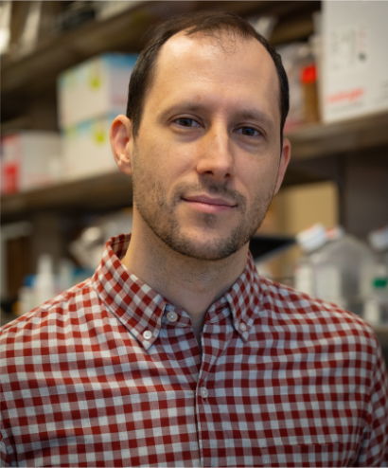
Characterization of immune-endothelial interactions during lung regeneration
The major function of the lungs is to bring oxygen into our body and remove carbon dioxide. Viral infections like influenza and COVID-19 can cause severe damage to the lungs that prevents this from happening. After viral infections, scar tissue forms in severely damaged parts of the lung. If enough scar tissue forms, oxygen can’t enter the body normally and in severe cases this can lead to death. My previous work has shown that the blood vessels within this scar tissue do not appear to function normally. The experiments I propose seek to understand why and how these blood vessels are not functioning normally so that we can try to correct this problem and replace the scar tissue with normal lung tissue.

Mentor: Edward E. Morrisey, PhD
Institution: The Trustees of the University of Pennsylvania

Kevin P. Seitz, MD, MSCR
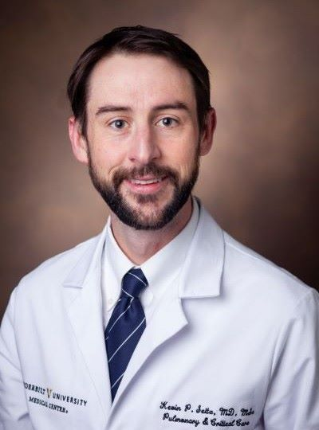
Effect of Ventilator Mode on Critically Ill Adults: A Multisite Pragmatic Trial
Every year, millions of adults require a breathing machine for life support, but one-in-three will die before leaving the hospital. On each breathing machine, clinicians must choose a mode, which is a setting that determines how the machine controls each breath. Which mode is best for patients, however, is unknown. Even small improvements in the safety of breathing machines could save thousands of lives each year. We designed the Mode of Ventilation During Critical Illness at Multiple Centers (MODEM) trial to determine which mode (volume control, pressure control, or adaptive pressure control) leads to more days alive and free of a breathing machine. To ensure the MODEM trial can answer that question, we will use implementation science to optimize how clinicians use the modes.

Mentor: Todd W. Rice, MD, MSC
Institution: Vanderbilt University Medical Center

Ann-Marcia C. Tukpah, MPH, MD, MS

Systemic Sclerosis Interstitial Lung Disease Prediction and Plasma Proteomic Profiling
Systemic sclerosis (SSc) is a multiorgan, scarring disease, and interstitial lung disease (ILD) is the leading cause of death for patients with SSc. There are significant adverse health outcomes of ILD and it remains poorly understood which patients will develop ILD, will experience lung function decline over time and reliable blood tests for SSc-ILD diagnosis are lacking. This project aims to use different data types: electronic health records (EHR), biobank samples; with machine learning techniques and tests of blood proteins to help understand new risk factors for SSc-ILD, predict SSc-ILD, and identify proteins that may be used for diagnosis. These results can help in promoting earlier disease detection and possibly help reduce the risk of irreversible and progressive lung scarring.

Mentor: Gary Matthew Hunninghake, MD, MPH
Institution: The Brigham and Women’s Hospital
Jingzhou Zhang, MD, MPH

Obesity-Related Determinants of COPD Heterogeneity: A Multiomics Investigation
Chronic obstructive pulmonary disease (COPD) is a deadly lung disease affecting millions of people worldwide. Patients with COPD show diverse features and outcomes. Despite its significant health impact, treatments are limited due to gaps in understanding the disease's variations and causes. Many patients with COPD are overweight, but how obesity affects their condition remains unclear. This study seeks to explain how obesity-related genetic factors influence COPD development and outcomes and identify the biological mechanisms involved. To achieve this, I will use advanced methods to analyze genetic data and blood molecules in large studies. By clarifying the relationship between obesity and COPD, this research could lead to the discovery of new therapeutic targets, improving treatment options for patients with COPD.

Mentor: George T. O’Connor, MD, MS
Institution: Trustees of Boston University, BUMC

David R. Ziehr, MD
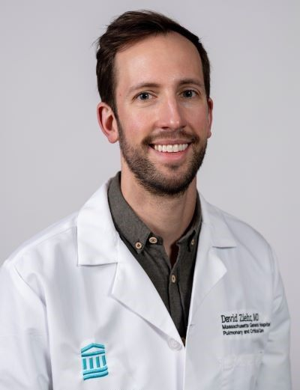
Causes and consequences of dysregulated lipid metabolism in genetic lung disease
Lung scarring, or fibrosis, is a deadly condition with two modestly effective therapies and no cure. While research on fibrotic lung tissue has taught us a lot, these studies are limited by the cellular heterogeneity of the fibrotic lung and challenges distinguishing events that trigger fibrosis from the complicated sequence of events that follow. Strikingly, in Hermansky-Pudlak syndrome, mutations that affect a specific cellular compartment (the lysosome) in a specific cell (the type II alveolar epithelial cell) are sufficient to cause fibrosis early in life. Our work combines genetic models of fibrosis and advanced molecular tools to isolate lysosomes from these specific epithelial cells. By understanding the molecular events triggered by fibrosis mutations, we hope to identify ways to treat many types of lung fibrosis.

Mentor: Jayaraj Rajagopal, MD
Institution: The General Hospital Corporation dba Massachusetts General Hospital

