

Press Release
FOR IMMEDIATE RELEASE
Michael Carlson
michael.e.carlson@Vanderbilt.Edu

HAGOOD, an art exhibition exploring memory, family, and Black Southern womanhood by sisters Lanecia and Ciona Rouse, opening at The Curb Center
Wednesday, August 27, 2025

Hagood, South Carolina: a town of fewer than 6,000 people, the birthplace of Great-Great-Grandmother Annie, the maternal origin of sisters Lanecia and Ciona Rouse, and a home—of sorts.
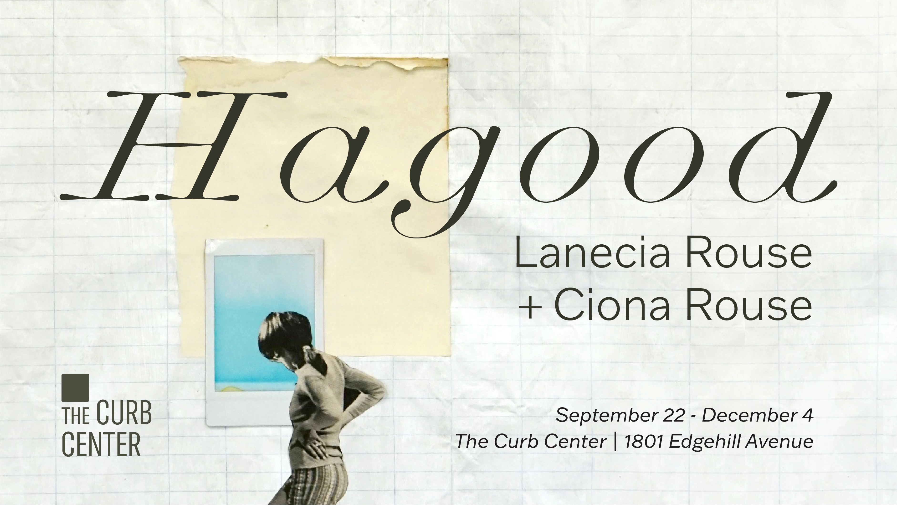
Nashville, Tennessee. (August 27, 2025) — HAGOOD is a collaboration between sisters that explores their matrilineal line through mixed media collage, installation, color meditations and poetry. This exhibition will be open from September 22nd to December 4th with visiting hours Monday through Thursday from 10:00 am to 4:00 pm, as well as Fridays and weekends by appointment, at The Curb Center, located at 1801 Edgehill Ave. The artists will host two Kindred artmaking workshops where participants will explore familial connections, lineage, and memory through writing and collage on September 24th from 4 to 6 pm and on November 1st from 11 am to 2 pm. Spots are limited: RSVP for the September workshop here and the November workshop here.
“It [Hagood, NC] is where our maternal living memory begins,” writes poet Ciona Rouse. “Hagood is a sort of home—even though it mostly exists for us in our infant memory. But there’s something about the South, something about being Black in the South, something about being Black and woman in the South that makes looking back a necessary way forward.”

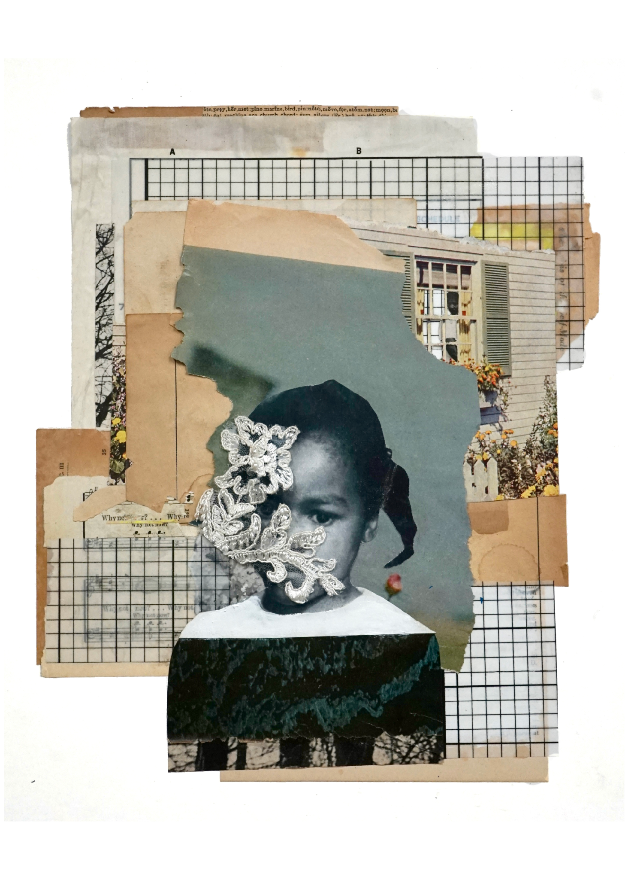
This exhibition is part of The Curb Center’s semester-long exploration of “Rememory,” a concept defined by Toni Morrison in her novel, Beloved. Rememory refers to collective memories, especially those connected to trauma, that can be recollected in some way by those who were not present for those experiences. "If a house burns down, it’s gone, but the place—the picture of it—stays, and not just in my rememory, but out there, in the world” says Sethe, the protagonist of Beloved, “What I remember is a picture floating around out there outside my head. I mean, even if I don’t think it, even if I die, the picture of what I did, or knew, or saw is still out there. Right in the place where it happened.”
Lanecia Rouse is the inaugural recipient of the Berg Global Artist-In-Residence Fellowship and will be working with Vanderbilt faculty and students throughout the Fall semester. She is a multifaceted visual artist whose practice includes collage, photography, abstract painting, curation, writing, and teaching. Her work has been exhibited by the University Museum of Texas Southern University, Reynolds Gallery, Second Street Gallery, and Zeitgeist Gallery among others. Her work was featured in Multiplicity: Blackness in Contemporary American Collage, which debuted at the Frist Art Museum in Nashville, TN before traveling to the Museum of Fine Arts, Houston, TX, and the Phillips Collection in Washington, D.C.

Ciona Rouse is a poet, editor, and author of Vantablack, a chapbook from Third Man Books (2017). Her work has appeared in Oxford American, Wildness, Booth, The Account, Still, Talking River, Gabby Journal, Matter: a journal of political poetry and commentary and elsewhere. She served as a resident poet for the Nick Cave: FEAT exhibition at Frist Art Museum, culminating in a poem called “We,” which was named 2018’s “Best Poetry Performance” by Nashville Scene.
Press kit can be accessed here.

You can learn more about HAGOOD and other Curb Center programs on our Instagram, @curbcenter, or on our website.
###
________________________________________________________________________
About The Curb Center
The Curb Center for Art, Enterprise & Public Policy is an interdisciplinary arts center aiming to elevate art as a mode of inquiry, a way of understanding, and a celebration of the human spirit at Vanderbilt and beyond. Through programs that serve Vanderbilt students, faculty, and staff as well as the broader Nashville community, the Curb Center positions art as a tool for investigating critical questions, understanding the complex challenges facing our world, and flourishing through creative and artistic expression.
For additional information, feel free to contact Michael Carlson at michael.e.carlson@Vanderbilt.Edu

